
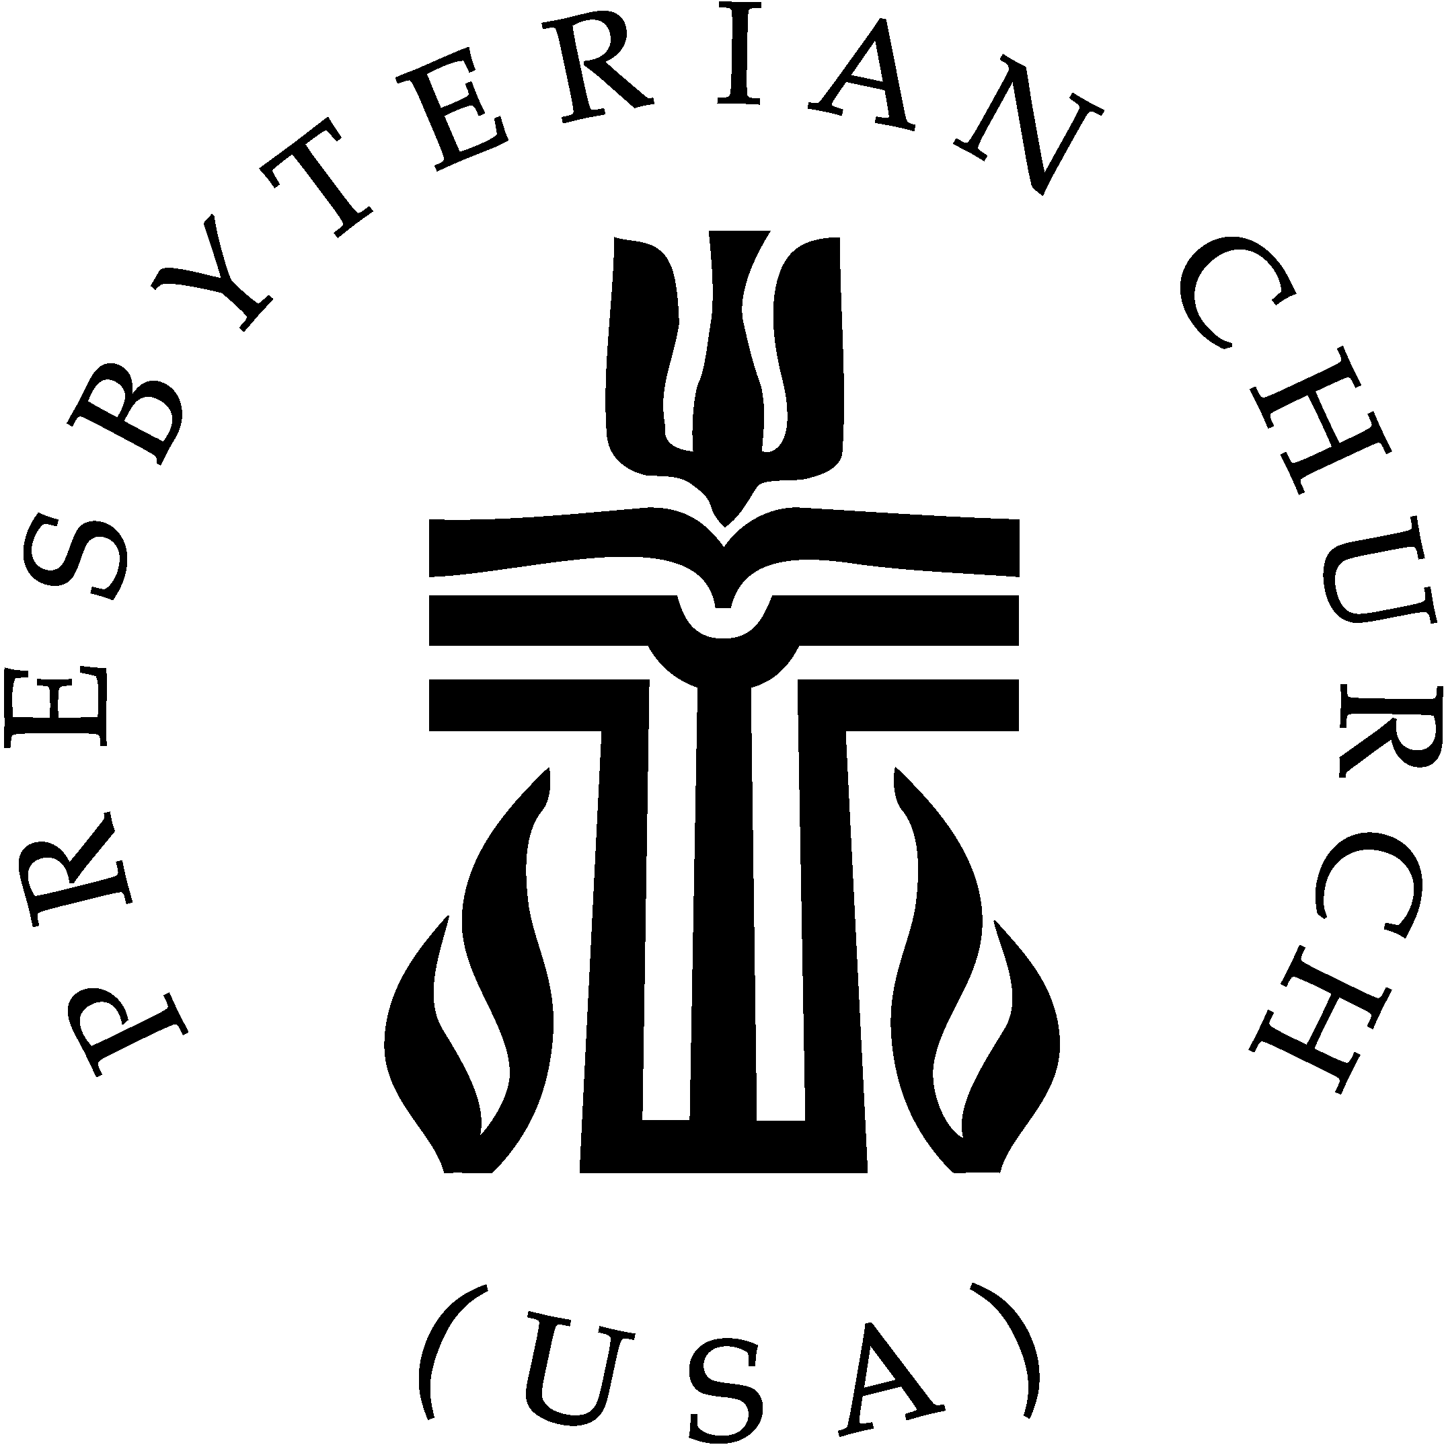
First Presbyterian Church

Sixth Sunday after Pentecost
July 05, 2026, 11:00 AM

* Indicates that those who are able may stand Bold type is spoken by the people.

WELCOME & ANNOUNCEMENTS
VOLUNTARY: Come, Thou Fount of Every Blessing Paul Thurmond
*CALL TO WORSHIP Rev. Katie Long, Liturgist
ONE: The Spirit of the Lord is here;
ALL: let us humble ourselves.

*OPENING HYMN: Come, Thou Fount of Every Blessing #475

CALL TO & PRAYER OF CONFESSION
ONE God is merciful and gracious, slow to anger and abounding in steadfast love. Knowing that God is compassionate to all, let us confess our sins, saying…
ALL: Faithful One, Despite our best efforts, we have not lived up to what we can do or who we can be. Even when our intentions are good, our actions cause harm. Even when we want to follow you more closely, we end up turning away. We are at war with ourselves, and only you can bring peace. Still our souls, order our steps, guide our feet back to your way.

SILENT PERSONAL CONFESSION

*RESPONSE HYMN: Lord Have Mercy Upon Us #575
*ASSURANCE OF PARDON
ONE: God upholds all who are falling, and raises up those who are bowed down.
ALL: Jesus Christ rescues us from sin and death; thanks be to God through Jesus Christ our Lord!

*GLORIA PATRI #581
Glory be to the Father, and to the Son, and to the Holy Ghost;
As it was in the beginning, is now and ever shall be, world without end. Amen!

TIME FOR YOUNG DISCIPLES Rev. Katie Long
PRAYER FOR ILLUMINATION
FIRST SCRIPTURE LESSON: Genesis 24:34-38, 42-49, 58-67 P.19
SECOND SCRIPTURE LESSON: Romans 7:15-25a P.147
ONE: Keep these words in your heart. The Lord is our God, the Lord alone.
ALL: Thanks be to God.

THIRD SCRIPTURE LESSON: Matthew 11:16–19, 25–30 P.11
SERMON Rev. Michael McLaughlin
*SERMON HYMN: Just a Closer Walk with Thee #835

COMMUNAL AFFIRMATION OF FAITH Confession of 1967, 9.32-33
The life, death, resurrection, and promised coming of Jesus Christ has set the pattern for the church’s mission. His human life involves the church in the common life of all people. His service to men and women commits the church to work for every form of human well-being. His suffering makes the church sensitive to all human suffering so that it sees the face of Christ in the faces of persons in every kind of need. His crucifixion discloses to the church God’s judgment on the inhumanity that marks human relations, and the awful consequences of the church’s own complicity in injustice. In the power of the risen Christ and the hope of his coming, the church sees the promise of God’s renewal of human life in society and of God’s victory over all wrong. The church follows this pattern in the form of its life and in the method of its action. So to live and serve is to confess Christ as Lord.

*GREETINGS
After an exchange of Peace between the Pastor and the Congregation, we encourage you to greet one another. The Greetings will conclude with the first verse of Blest Be the Tie That Binds.

ONE: …The Peace of the Lord Jesus Christ be with you all.
ALL: And also with you.

Blest be the tie that binds our hearts in Christian love; #306
The fellowship of kindred minds is like to that above.

PRAYERS OF THE PEOPLE
ONE: … Lord, in your mercy,
ALL: hear our prayer.

INVITATION TO GIVING

OFFERTORY SOLO: Cantique Nadia Boulanger Rachel Young, soloist

To all weeping souls, to all passing sins,
I open, cradled by stars, my hands full of grace.
No sin can live when love has spoken,
No soul can die then love has wept.
And if love goes astray on terrestrial paths,
Its tears will find me and not go astray.

OFFERING

*DOXOLOGY #606

ALL: Praise God, from whom all blessings flow; Praise God, all creatures here below; Praise God above, ye heavenly host; Praise Father, Son, and Holy Ghost. Amen.

*PRAYER OF DEDICATION
THE SACRAMENT OF THE LORD’S SUPPER
INVITATION TO THE LORD’S TABLE
THE GREAT THANKSGIVING

ONE: The Lord be with you.
ALL: And also with you.
ONE: Lift up your hearts.
ALL: We lift them up to the Lord.
ONE: Let us give thanks to the Lord our God.
ALL: It is right to give our thanks and praise.
ONE: …Therefore we praise you, joining the song of the universal church and the heavenly choir:

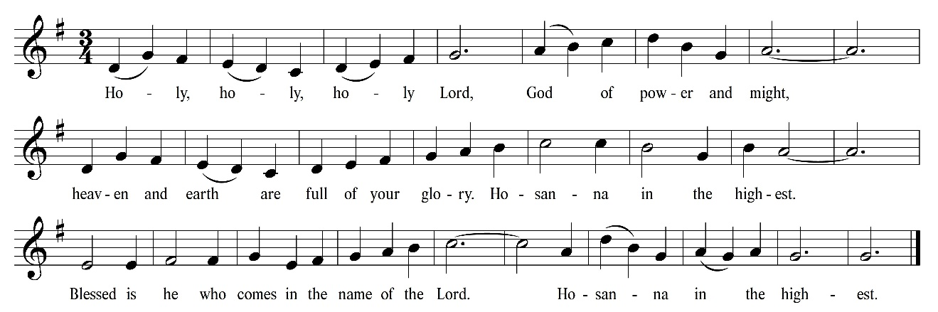
ALL: Holy, Holy, Holy #572
ONE: …Remembering your goodness and grace, we offer ourselves to you with gratitude as we share this joyful feast.
ALL: Christ has died, Christ is risen, Christ will come again.

THE LORD’S PRAYER

Our Father, who art in heaven, hallowed be thy name, thy kingdom come, thy will be done, on earth as it is in heaven. Give us this day our daily bread; and forgive us our debts, as we forgive our debtors; and lead us not into temptation, but deliver us from evil. For thine is the kingdom, and the power, and the glory, forever. Amen.

COMMUNION OF THE PEOPLE
PRAYER AFTER COMMUNION
*CLOSING HYMN: We Come as Guests Invited #504
*BENEDICTION

POSTLUDE: Fugue William Woland

Website: www.firstprescookeville.org
Church Office: Tue.-Thur. 8:30am-2:30 pm
Telephone: (931) 526-4424, E-Mail: office@firstprescookeville.org

